
Student Number
Mark / 63

Chemistry

Final Examination
Preliminary Course • 2004

General Instructions

•Reading time – 5 minutes
•Working time – 120 minutes
•Write using black or blue pen
•Draw diagrams using pencil
•Board-approved calculators may be used
•A Data Sheet and a Periodic Table
are provided at the back of this paper
and may be removed for convenience
•Write your Student Number at the top
of this page
Total Marks – 63

Part A – 15 marks
•Attempt Questions 1 – 15
•Allow about 30 minutes for this part

Part B – 48 marks
•Attempt Questions 16 – 27
•Allow about 90 minutes for this part

This page is intentionally blank.



JRAHS Year 11 Chemistry Final Exam – 2004 Page 2 of 18
Part A – 15 marks
Attempt Questions 1–15
Allow about 30 minutes for this part

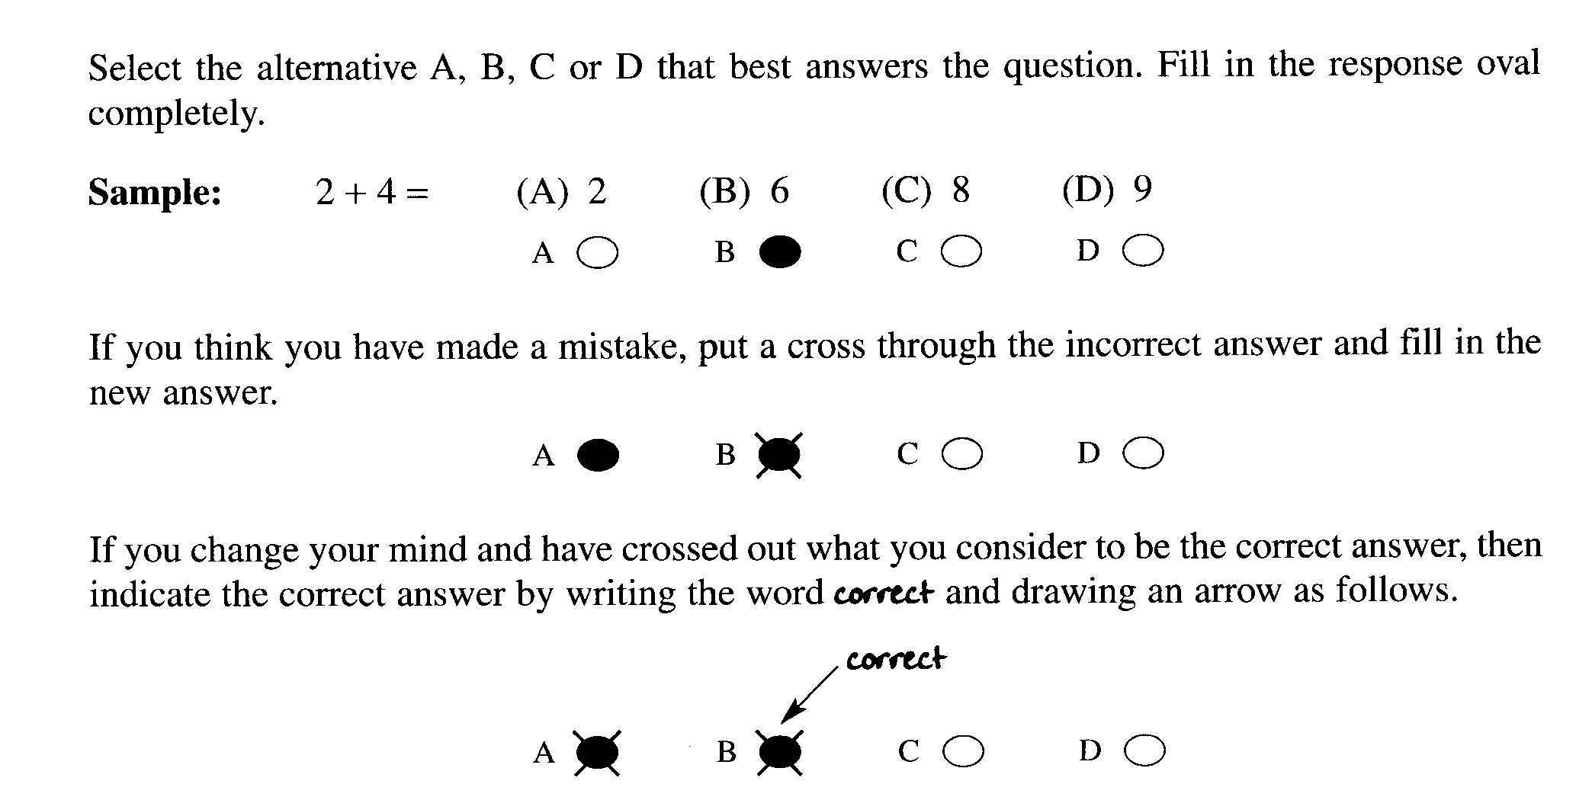

Answer Box for Questions 1–15
1 | A ○ | B ○ | C ○ | D ○
2 | A ○ | B ○ | C ○ | D ○
3 | A ○ | B ○ | C ○ | D ○
4 | A ○ | B ○ | C ○ | D ○
5 | A ○ | B ○ | C ○ | D ○
6 | A ○ | B ○ | C ○ | D ○
7 | A ○ | B ○ | C ○ | D ○
8 | A ○ | B ○ | C ○ | D ○
9 | A ○ | B ○ | C ○ | D ○
10 | A ○ | B ○ | C ○ | D ○
11 | A ○ | B ○ | C ○ | D ○
12 | A ○ | B ○ | C ○ | D ○
13 | A ○ | B ○ | C ○ | D ○
14 | A ○ | B ○ | C ○ | D ○
15 | A ○ | B ○ | C ○ | D ○

JRAHS Year 11 Chemistry Final Exam – 2004 Page 3 of 18

► Mark your answers for Questions 1 – 15 in the Answer Box on page 3.

1 The diagram shows the volume of water displaced when an insoluble solid is placed in a measuring cylinder containing water. The mass of the solid is 5.70 g. ► Bottom of cylinder is truncated.
10 mL
20 mL
10 mL
20 mL
before solid placed in water
after solid placed in water

What is the density of the solid?

(A) 0.308 g mL ^{–1}
(B) 1.90 g mL ^{–1}
(C) 2.10 g mL ^{–1}
(D) 28.0 g mL ^{–1}

2 What does ‘m’ represent in the equation… ∆H = – m C ∆T?

(A) molar mass of the reactant chemical
(B) molarity of the final solution
(C) mass of the substance being heated or cooled
(D) moles of the reactant chemical

3 A solution is prepared by dissolving 1.50 g of Ca(OH)₂ in enough water to produce 1.00 L of solution.
What is the concentration of the hydroxide ions in the solution?

(A) 3.00 g L ^{–1}
(B) 2.00 × 10^{–2} mol L ^{–1}
(C) 4.00 × 10^{–2} mol L ^{–1}
(D) 1.50 × 10^{–2} g L ^{–1}

JRAHS Year 11 Chemistry Final Exam – 2004 Page 4 of 18

4 Which of the following is both an empirical formula and a molecular formula?

(A) CO
(B) C₃H₆
(C) CuSO₄ ∙ 5H₂O
(D) NaCl

5 Which of the statements is a consequence of Avogadro’s Law?

(A) The volume of one mole of CO and one mole of He are both 24.79 L at 25°C and 100 kPa.
(B) One mole of a compound contains 6.022 × 10²³ molecules of that compound.
(C) Mass divided by the molar mass gives the number of moles.
(D) Gases expand when heated.

6 Which diagram shows the bonding between a water molecule and an ammonia molecule?

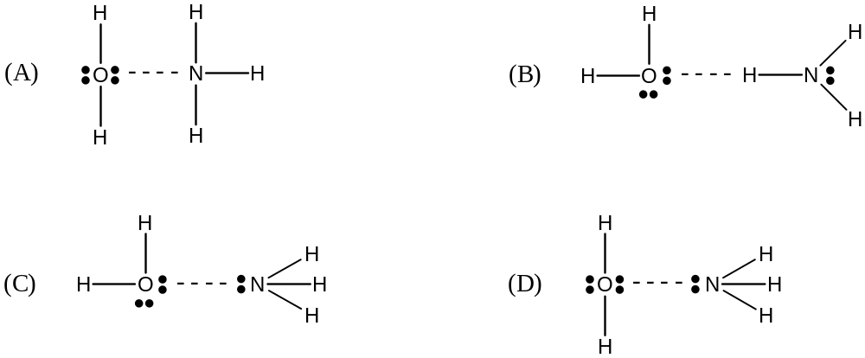

7 When one mole of sodium hydroxide is completely dissolved in water 41.6 kJ of heat energy is released. A chemistry class performed a simple calorimetry experiment to determine this value and all of the students got results lower than the accepted value.

Which statement best explains the reason for the lower values obtained?

(A) The thermometers used were inaccurate.
(B) The mass of water in the cup was not accurately measured.
(C) The students didn’t wait long enough for the final temperature to stabilise.
(D) Not all the heat produced by the dissolution was absorbed by the calorimeter.

JRAHS Year 11 Chemistry Final Exam – 2004 Page 5 of 18

8 100 mL of salt water was heated in a flask from 20°C to boiling.
Which graph best represents the heating curve?
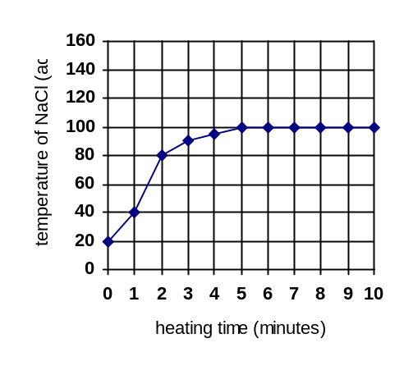

(A)

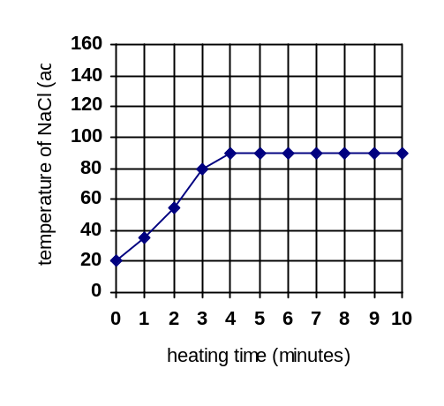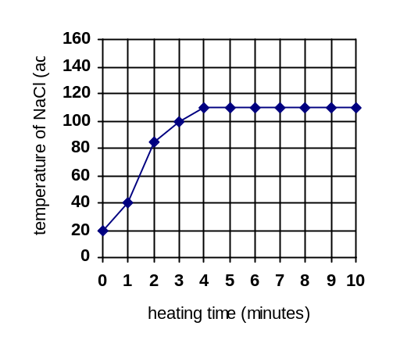

(B)

(C)

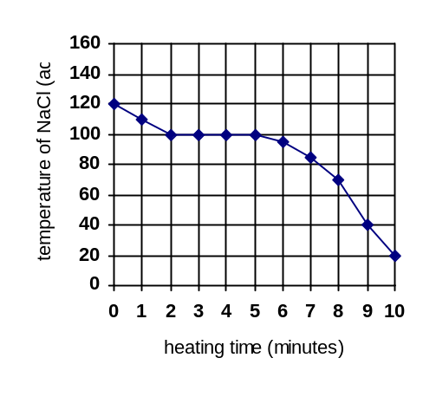

(D)

JRAHS Year 11 Chemistry Final Exam – 2004 Page 6 of 18

Questions 9 and 10 refer to the energy level diagram for the reaction…

½ H₂ _{(g)} + ½ F₂ _{(g)} ⇋ HF _{(g)} ∆H = – 64 kJ mol ^{–1}
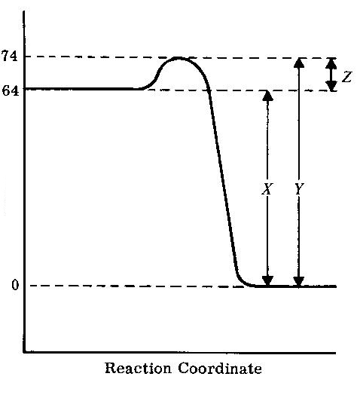
Energy ( kJ mol ^{–1} )

9 Which statement is incorrect?

(A) The activation energy per mole of hydrogen fluoride formed is 10 kJ mol ^{–1}.
(B) The activation energy of the reverse reaction is 74 kJ mol ^{–1}.
(C) The heat of reaction per mole of hydrogen fluoride is represented by the value of X.
(D) The heat of reaction is 64 kJ mol ^{–1} of fluorine reacted.

10 What effect would adding a catalyst have on the reaction?

(A) X would stay the same and Y would become smaller.
(B) X would become smaller and Y would become larger.
(C) Both X and Y would become smaller.
(D) Z would become larger.

11 Which physical property of water can be used to explain its relatively high values for surface tension and boiling point?

(A) strong intermolecular forces
(B) low molecular mass
(C) low viscosity
(D) high solvency

JRAHS Year 11 Chemistry Final Exam – 2004 Page 7 of 18

12 Hydrogen chloride has a very high solubility in water = 70 g per 100 g H₂O at 20°C.

Which intermolecular force best explains this high aqueous solubility?

(A) dispersion force
(B) dipole – dipole force
(C) hydrogen bonding
(D) all of the above

13 To which of these reactions can Guy–Lussac’s law be applied?

(A) Fe _{(s)} + S _{(s)} → FeS _{(s)}
(B) 2H_{2 (g)} + O_{2 (g)} → 2H₂O _{(g)}
(C) Ba²⁺_{(aq)} + SO₄^{2–}_{(aq)} → BaSO₄ _{(s)}
(D) HCl _{(aq)} + NaOH _{(aq)} → NaCl _{(aq)} + H₂O _{(l)}

14 One mole samples of metals are completely reacted in oxygen gas to form metal oxides.
The table shows the formulae results…

metal | metal oxide formed
Na | Na₂O
Mg | MgO
Al | Al₂O₃
Ni | NiO₂

Which metal requires the most moles of oxygen to form an oxide?

(A) Na
(B) Mg
(C) Al
(D) Ni

15 Which of these solute types is insoluble in water?

(A) non–polar covalent
(B) covalent network
(C) large molecular
(D) all of the above

JRAHS Year 11 Chemistry Final Exam – 2004 Page 8 of 18

Part B – 48 marks
Attempt Questions 16 – 27
Allow about 90 minutes for this part

► Show all relevant working in questions involving calculations.

Question 16 (2 marks)

Construct Lewis electron dot structures for water and hydrogen sulfide…

WATER | HYDROGEN SULFIDE

Question 17 (3 marks)

Identify whether the compound is soluble (s) or insoluble (i) in water…

Compound | NaCl | sucrose | NaOH | HCl | cellulose | SiO₂
s or i ?

Question 18 (4 marks)

(a) Identify the physical property of water which explains its ability to moderate the temperature of aquatic environments. (1 mark)
___________________________________________________________________________________

(b) Thermal pollution can cause serious environmental problems in waterways.

(i) Identify a source of thermal pollution. (1 mark)

_____________________________________________________________________________

(ii) Discuss the implications for life if a body of water is affected by thermal pollution. (2 marks)

_____________________________________________________________________________

_____________________________________________________________________________

_____________________________________________________________________________

JRAHS Year 11 Chemistry Final Exam – 2004 Page 9 of 18

Question 19 (2 marks)

The diagrams show the crystal structures of diamond and ice…
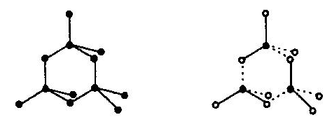

diamond ice

Describe how these crystals are held together.

_________________________________________________________________________________________

_________________________________________________________________________________________

_________________________________________________________________________________________

Question 20 (6 marks)

When nickel(II) chloride (NiCl₂) solution is added to sodium hydroxide solution, a green precipitate forms.

(a) Write the net ionic equation for the reaction. (1 mark)

___________________________________________________________________________________

(b) In one reaction, 60 mL of 0.20 mol L ^{–1} sodium hydroxide is added to 40 mL of 0.50 mol L ^{–1} solution of NiCl₂.

(i) Calculate the mass of precipitate formed. (3 marks)

_____________________________________________________________________________

_____________________________________________________________________________

_____________________________________________________________________________

_____________________________________________________________________________

_____________________________________________________________________________

JRAHS Year 11 Chemistry Final Exam – 2004 Question 20 continued on page 11 Page 10 of 18

Question 20 (continued)

(ii) Calculate the concentration of chloride ions in the final solution. (2 marks)

_____________________________________________________________________________

_____________________________________________________________________________

_____________________________________________________________________________

Question 21 (6 marks)

Weighed samples of aluminium and magnesium were reacted with excess dilute hydrochloric acid solution,
each metal–acid reaction producing hydrogen gas. The table shows the masses of metal reacted and the resultant volume of hydrogen gas produced at 25°C and 100 kPa.

metal | mass of metal (g) | volume of h₂ (mL)
Al | 0.108 | 150
Mg | 0.0973 | 100

(a) From the data in the table above, calculate these quantities… (2 marks)

metal | moles of metal reacted | moles of h₂ produced
Al
Mg

(b) What is the mole ratio between each of the metal reacted and the hydrogen gas produced? (1 mark)
Al : H₂ | Mg : H₂
: | :

(c) Write the balanced formulae equations for the reactions of each metal with dilute HCl. (2 marks)

___________________________________________________________________________________

___________________________________________________________________________________

JRAHS Year 11 Chemistry Final Exam – 2004 Question 21 continued on page 12 Page 11 of 18

Question 21 (continued)

(d) Do the equations in (c) support the results of the experiment? Explain. (1 mark)

___________________________________________________________________________________

___________________________________________________________________________________

___________________________________________________________________________________

Question 22 (2 marks)

15.9 grams of potassium dichromate (K₂Cr₂O₇) are dissolved in a sufficient amount of water to make up exactly 250 mL of solution.

What is the concentration of the solution? (2 marks)

_________________________________________________________________________________________

_________________________________________________________________________________________

_________________________________________________________________________________________

_________________________________________________________________________________________

Question 23 (1 mark)

How many hydrogen atoms are present in 25.6 g of urea, (NH₂)₂CO?

_________________________________________________________________________________________

_________________________________________________________________________________________

_________________________________________________________________________________________

_________________________________________________________________________________________

JRAHS Year 11 Chemistry Final Exam – 2004 Page 12 of 18

Question 24 (6 marks)

Nikita performs a simple calorimetry experiment to determine the molar ∆H_{solution} for KOH.
The table shows her experimental data …

Mass of water in calorimeter | 150 g
Mass of KOH dissolved | 5.6 g
Initial temperature of water | 18°C
Final temperature of water | 27°C

(a) Calculate the molar ∆H_{solution} for KOH using Nikita’s data. (3 marks)

_________________________________________________________________________________________

_________________________________________________________________________________________

_________________________________________________________________________________________

_________________________________________________________________________________________

_________________________________________________________________________________________

_________________________________________________________________________________________

_________________________________________________________________________________________

(b) KOH is also soluble in ethanol. Nikita plans to repeat the experiment using ethanol as the solvent instead of water and she thinks about the changes to the equation… ∆H = – m C ∆T
(i) Compare (relatively) the specific heat capacity (C) of ethanol with the value of water. (1 mark)

_____________________________________________________________________________

(ii) Considering your answer in (i), predict the effect on the ΔT, i.e. will it decrease, increase or
remain the same compared to the ΔT of water? (1 mark)

_____________________________________________________________________________

(c) Identify a salt where ∆H_{solution} is endothermic. (1 mark)

___________________________________________________________________________________

JRAHS Year 11 Chemistry Final Exam – 2004 Page 13 of 18

Question 25 (5 marks)

(a) Kiely conducts a series of investigations on factors which effect reaction rate. In trial 1, she reacts a one centimetre cube (1 cm³) of magnesium weighing 1.74 g with 200 mL of 3 mol L ^{–1} HCl in a beaker.
In trial 2, she reacts eight ½ centimetre cubes (total weight = 1.74 g) simultaneously in a beaker.

TRIAL 1 TRIAL 2

Identify which trial has the fastest rate and identify the factor which causes the effect. (1 mark)

___________________________________________________________________________________

___________________________________________________________________________________

(b) Kiely broadens her investigation and explores the effects of temperature and concentration on reaction rate.

(i) What effect would you predict for temperature variations and how is this effect explained on a particle level? (2 marks)

___________________________________________________________________________________

___________________________________________________________________________________

___________________________________________________________________________________

(ii) What effect would you predict for concentration variations and how is this effect explained on a particle level? (2 marks)

___________________________________________________________________________________

___________________________________________________________________________________

___________________________________________________________________________________

JRAHS Year 11 Chemistry Final Exam – 2004 Page 14 of 18

Question 26 (4 marks)

Propanone (C₃H₆O) is a flammable liquid used extensively as a solvent.

(a) Write a balanced chemical equation showing the complete combustion of propanone. (1 mark)

___________________________________________________________________________________

(b) Write a balanced chemical equation showing the incomplete combustion of propanone. (1 mark)

___________________________________________________________________________________

(c) Identify a pollutant produced in equation (b) and explain how its production can be avoided. (2 marks)

___________________________________________________________________________________

___________________________________________________________________________________

Question 27 (7 marks)

(a) Complete the energy level diagram by drawing in a curve for an endothermic reaction… (1 mark)

Reaction coordinate
Energy

(b) In the diagram, draw a dashed ( – – – – ) line showing the effect of employing a catalyst. (1 mark)

JRAHS Year 11 Chemistry Final Exam – 2004 Question 27 continued on page 16 Page 15 of 18

Question 27 (continued)

(c) Explain how a catalyst speeds up reaction rate. (1 mark)

___________________________________________________________________________________

___________________________________________________________________________________

(d) Identify a catalyst used in industry. (1 mark)

___________________________________________________________________________________

(e) Study the four energy level diagrams (I – IV) …

I
II
III
IV

(i) Which diagram best represents the most easily ignitable fuel? ______ (1 mark)

(ii) Which diagram best represents a fuel with the highest ignition temperature? ______ (1 mark)

(f) Complete the graph by drawing in a line or curve showing the relative relationship between the
kinetic energy of particles and the temperature as they are heated up… (1 mark)

Kinetic Energy
Temperature

JRAHS Year 11 Chemistry Final Exam – 2004 end of exam Page 16 of 18

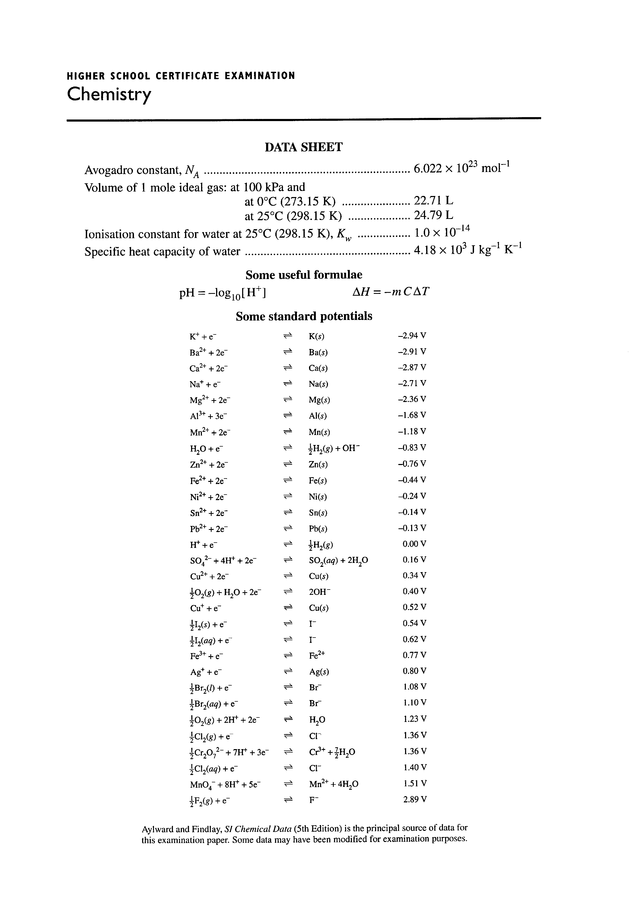
JRAHS Year 11 Chemistry Final Exam – 2004 Page 17 of 18
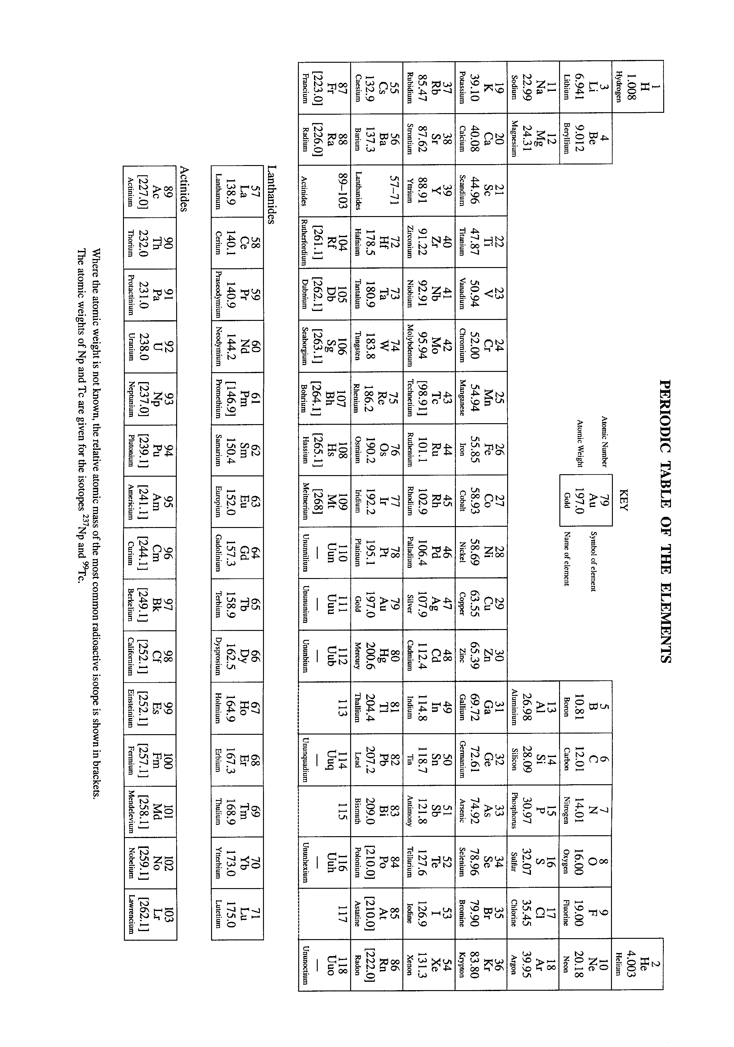
JRAHS Year 11 Chemistry Final Exam – 2004 Page 18 of 18

